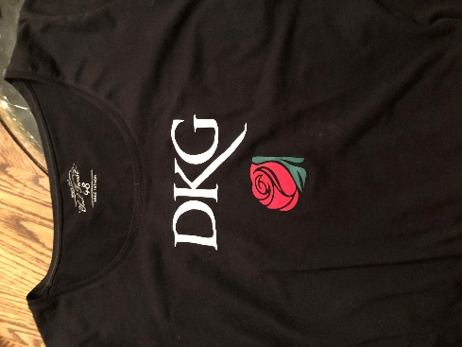
T-Shirt Pre-Order Form
Name: ____________________________
Email: ____________________________
Phone: ____________________________ **ORDER DEADLINE: MARCH 1, 2024
Chapter: ____________________________
All profits will go to DKG Alpha Chi Nevada State!
***Black cotton t-shirt with DKG white lettering and a red rose applique
***Please mark short or long-sleeve; round or V-neck:
____Short-sleeve: $20.00 each x _______ = TOTAL $___________ (check or cash)
____ round neck ____ V-neck
____Long-sleeve: $23.00 each x _______ = TOTAL $___________ (check or cash)
____ round neck ____ V-neck
***Please specify your size:
Women’s XS ____ S ____ M ____ L ____ XL ____ 2XL ____ 3XL ____ 4XL ____
Men’s XS ____ S ____ M ____ L ____ XL ____ 2XL ____ 3XL ____ 4XL ____

T-shirts will be automatically delivered to Chapter Presidents to distribute to their members. If you’d like yours mailed directly to you, please indicate below:

Shipping: $5.00 (+ $1.00 per each additional t-shirt); Shipping Total = $_________
Mailing Address _____________________________________________________________

**Include check or cash with order form!
Contact: Cheryl Anderson 775-742-9056
P.O. Box 2832; Minden, NV 89423
Cherylanderson25@yahoo.com

***Send payment to Cheryl Anderson. Make checks payable to: Nevada–Delta Kappa Gamma.

